***Eclipso Final Report***

**Team names and student numbers**

Aaron Gill: 100359038

Timothy McDermott: 100351319

Liam Harder: 100376013

**Class Information**

Assignment 3

Course #: INFO 1113

Section #: S11

Instructor: Abhijit Sen

Date: Nov.13 2019

**Websites and links**

Eclipso Website: <https://sites.google.com/view/timothy-mcdermott-eclipso/home>

GitHub Sites:

Aaron: <https://github.com/aarongill99/INFO-1113-Assignment3>

Timothy: <https://github.com/Tohserus/INFO-Assignment-3>

Liam: <https://github.com/liamharder/Eclipso>

Contents

Introduction 3

List of Functions 3

Use Case diagram 3

Use Case descriptions 4

Difficulties Faced while Generating Use-Case Diagram and Use-Case Descriptions 7

Conclusion 7

# Introduction

Hello! Welcome to the Eclipso final report, this will outline the Eclipso app with its functions, as well as a list of all use cases and descriptions of their actions/ uses. Along side displaying images of our use case diagram and individual use cases, to view individual team members Githubs, or the project website, scroll to the beginning of the report.

# List of Functions

Application goals of Eclipso.

* Display maps with upcoming solar or lunar eclipses and their trajectory across the planet.
* Allow users to set notifications for upcoming events.
* Allow users to specify what type of eclipses they are interested in.
* Allow users to set a range of interest.
* Show user’s comfortable places to view the eclipse.
* Display accommodation nearby.
* Give a heads up on the dangers of an eclipse, and how to counter these dangers.

# Use Case diagram

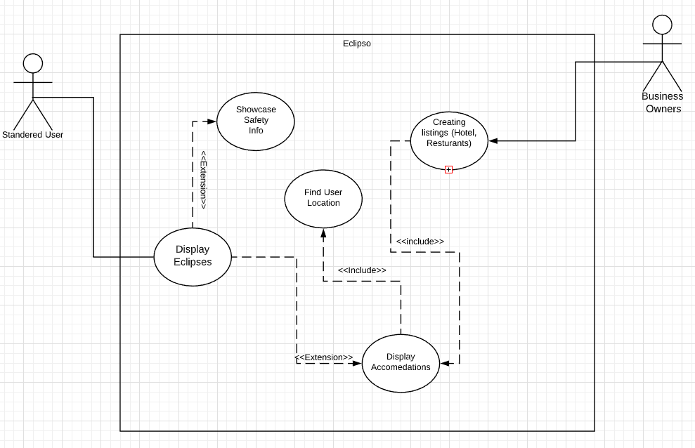

# Use Case descriptions

Use Case Title: Display Eclipses

Primary Actor: User

Level: Kite Level

Stakeholders: User, business owners

Preconditions: There must be eclipses in the database ready to be displayed.

Minimal Guarantee: It will show the user a map of the world.

Success Guarantee: User will be displayed a large map where they can see all future eclipses and can scroll around the globe to see more.

Trigger: User opens the Eclipso application.

Main Success Scenario:

1. User opens the Eclipso application.

2.  The application accesses the eclipse database, either stored within the application locally or data retrieved from online.

3. The application finds the eclipse and shows all the eclipses happening that year plotted on a map.

Extensions:

1.a.1. User opens the Eclipso application.

1.a.2.The application accesses the eclipse database, either stored within the application locally or data retrieved from online.

1.a.3.The application finds the eclipse and shows all the eclipses happening that year plotted on a map. The user chooses to click on one of the buttons:

o   Showcase Safety Info

§ Shows safety precautions and measures you can take to protect yourself.

o   Display Accommodations

§ (See below Display Accommodations Use Case)

Exceptions:

1. No Database detected

(1)   An error pops up on screen telling you:

(a)    If the database is local to reinstall the application.

(b)   If the database is retrieved from the internet, to try reconnecting.

(2)   Shows the map without plotted eclipse locations.

2. If no eclipses are happening within the specified timeframe.

(1)   Gives user option to choose date range.

**Created by: Aaron Gill Reviewed by: Timothy McDermott**

Use Case Title: Display Accommodation

Primary Actor: User

Level: Kite Level

Stakeholders: User, business owners

Precondition: User must have access to the internet to find updated and accurate listings, as well as enter in their current position for accurate listings.

Minimal Guarantee: App will show a list of restaurants, hotels, hot spots within the users selected range of interest, (As well as their GPS position).

Success Guarantee: App showcases accommodation to the user, their ratings, position in the eclipse and accessibility

Trigger: Use case begins when the user selects the “Accommodations” button from the display eclipses, which will bring them to an accommodation listing page.

Main Success Scenario:

1. App uses GPS or user entered location, as well as their entered range of interest.
2. App uses internet to update accommodation listings, new reviews, scores and locations
3. App displays to user all of the obtained into, and allows them to search the sites name.

Extensions:

1.a. App cannot find an internet connection to update listings

              1.a.1. App displays that it must have an internet connection to find accommodation

              1.a.2. App displays button to return to the main menu

2: GPS finds a wrong location, or a glitch happens with the user entered location

              2.a.1. user may go to settings and select to recalibrate their location

              2.a.2. App attempts to locate user using GPS

2.a.3. If the app cannot find the users location, ask user to enter their location (country, state/provinces/town)

**Created by: Timothy McDermott Reviewed by: Aaron Gill**

Use Case Title: Find User Location

Primary Actor: User

Level: Kite level

Stakeholders: User

Precondition: User must be using a device that allows for GPS location and has a working Internet connection

Minimal Guarantee: App will display global map of events and accommodations

Success Guarantee: User’s location will be recorded and used to determine local accommodations and events

Trigger: User attempts to find accommodations or events near their current location

Main Success Scenario:

1. App connects to location-finding service

2.  App sends GPS coordinates to service and receives location

3. App calculates distance to local points of interest from current location

Extensions:

1.a. Device cannot connect to location-finding service

            1.a.1. App displays error message for user and attempts to reconnect.

            1.a.2. App prompts user to enter location manually via street address or coordinates

            1.a.3. App is unable to determine location and simply displays global map

2.a. Service returns incorrect location

            2.a.1. App prompts user to confirm correct location

            2.a.2 App prompts user to enter location manually

**Created by: Liam Harder Reviewed by: Timothy McDermott**

# Difficulties Faced while Generating Use-Case Diagram and Use-Case Descriptions

We had some issues when formatting/merging our use case descriptions along side minor communication and scheduling difficulties. We also experienced differences when researching methods for uses case descriptions, leading to confusion as to which format we should make uniform. We couldn’t figure out how to implement sub-headings into table of contents.

# Conclusion

Many of the project’s functions require the ability to accurately and reliably pinpoint the user’s location, and as such a large amount of attention must be given to the algorithms and methods used to determine the user’s location. The application also requires rather large databases for storing accommodation data, which either means the application will take up a large chunk of memory on the user’s device or it will require reliable access to a remote server hosting the database.